Namespaces in Python
Namespaces in Python are dictionaries internally.

In a Python program, there are four types of namespaces:
- Built-In
- Global
- Enclosing
- Local

The Built-In Namespace
The built-in namespace contains the names of all of Python’s built-in objects.
print(dir(__builtins__))

The Python interpreter creates the built-in namespace when it starts up. This namespace remains in existence until the interpreter terminates.

The Global Namespace
The global namespace contains any names defined at the level of the main program
The interpreter also creates a global namespace for any module that your program loads with the import statement.

The globals() function
The built-in function globals() returns a reference to the current global namespace dictionary. You can use it to access the objects in the global namespace.

The locals() function
Python also provides a corresponding built-in function called locals(). It’s similar to globals() but accesses objects in the local namespace instead.

e.g. if your code refers to the name x, then Python searches for x in the following namespaces in the order shown:
- Local: If you refer to x inside a function, then the interpreter first searches for it in the innermost scope that’s local to that function.
- Enclosing: If x isn’t in the local scope but appears in a function that resides inside another function, then the interpreter searches in the enclosing function’s scope.
- Global: If neither of the above searches is fruitful, then the interpreter looks in the global scope next.
- Built-in: If it can’t find x anywhere else, then the interpreter tries the built-in scope.
This is called as the LEGB rule . The interpreter searches for a name from the inside out, looking in the local, enclosing, global, and finally the built-in scope:
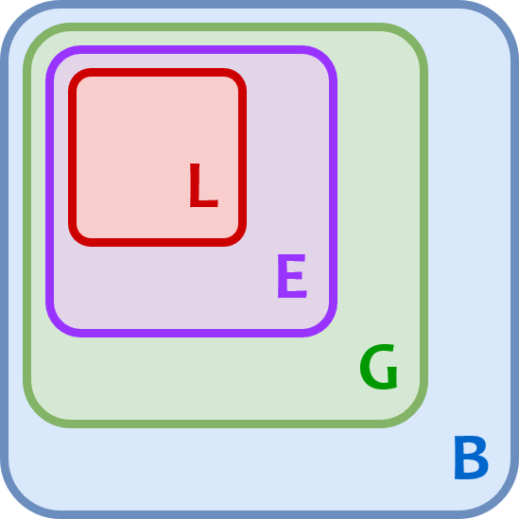

If the interpreter doesn’t find the name in any of these locations, then Python raises a NameError exception.

